**ACTIVITY AND WELLBEING MANAGER**

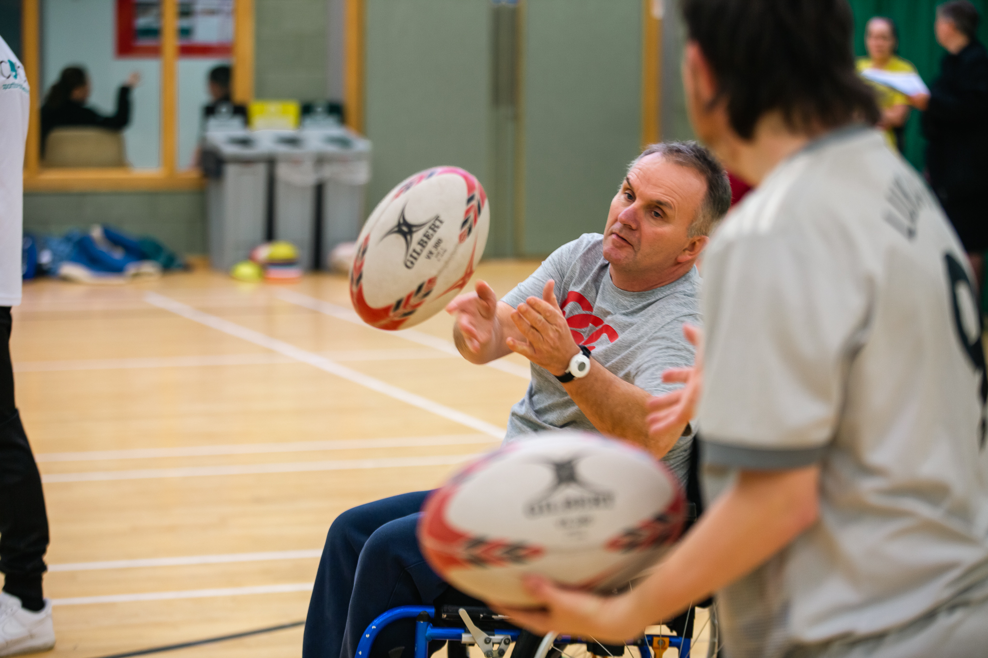

RECRUITMENT OPPORTUNITY



RECRUITMENT OPPORTUNITY

**Derby City**

**30 Hours per week – circa £29 - 31k FTE, plus colleague benefits**

**Everyone Active is on a mission to promote a healthier and more active lifestyle within our communities. Our brand is built on the belief that 30 minutes of activity, five times a week, can significantly improve an individual's health and wellbeing. We are currently seeking an enthusiastic and self-motivated individual to join our team as an Activity & Wellbeing Manager.**

**Responsibilities:** You will play a crucial role in achieving the local authority's strategic objectives with a specific focus on addressing health inequalities. Your responsibilities will include:

* **Strategic Planning:** Develop and implement a successful plan to address levels of inactivity among target groups, aligning with Everyone Active and the local authority
* **Community Engagement:** Actively engage with the local community to promote and encourage participation in activities that enhance health and wellbeing**.**
* **Partnership and Collaboration:** Work collaboratively with various partners, stakeholders, and organisations to create programmes that support the overall mission.
* **Programme Management:** Oversee the day-to-day operations of Activity and Wellbeing programs, both within the centre and through community outreach activities such as Exercise Referral, birthday parties, holiday activities and sports courses.
* **Commercial Sustainability:** Achieve revenue and budget targets for Activity and Wellbeing.
* **Team Leadership:** Effectively manage and lead a team of colleagues, ensuring a positive and collaborative working environment**.**
* **Programme Evaluation:** Evaluate the success and impact of programmes, presenting back to partners.

**Requirements:**

* Experience within leisure, sport development or health – increasing physical activity.
* An understanding of local community demographics.
* Demonstrated ability to work collaboratively with partners.
* Effective leadership and team management skills.
* Strong communication and presentation skills.

**If you are passionate about making a positive impact on the community, and you possess the skills and experience required for this role, we invite you to apply.**

**How to Apply:** Please send your CV and a cover letter detailing your relevant experience to LaurenSlater@everyoneactive.com. The deadline for applications is Sunday 30th March and Interviews to be held on Thursday 3rd April.