**South Derbyshire Healthy Communities Plan 2024/25**

|  |  |  |  |  |
| --- | --- | --- | --- | --- |
| **VISION**  Improving the health and wellbeing of people in South Derbyshire by supporting people to live healthier lives. | | | | |
| **PRIORITIES** | | | | |
| Health inequalities between different communities are reduced by building community resilience | People are supported to move more and become more active in everyday life | People are supported to age well, including those living with dementia and other long-term conditions,  and their carers | Improving emotional health and mental wellbeing | Enable children and young people to start well |
| **MEASURING SUCCESS – working to make a long-term difference** | | | | |
| * Improving average life expectancy * Reducing trend differences in life expectancy between areas of deprivation and affluence * Increased % of people aged 16-64 in employment * Reduced % of pupil absence | * Improved % of active adults * Decreased % of inactive adults * Reduced % of children and adults who are overweight or obese * Reduced trend in incidence of diseases such as diabetes | * Improving Health status score of people aged 65+ * Improving trend in life expectancy years post 65yrs * Reduce number emergency hospital admissions due to falls in age 65 and over | * Improving average life expectancy * Vulnerable populations * Reduced % of Hospital admissions for self-harm - 10-24 years * Reduce social isolation and loneliness | * Educational attainment improved * 16-17 year olds NEET reduced * Decrease smoking in pregnancy * Improve school readiness * Increase breastfeeding initiation rates * Reduce childhood poverty |
| **Objectives – what will we do?** | | | | |
| * Work through strong collaboration across multiple organisations, groups and empowering local people through an asset-based approach * Add value to services and programmes aimed to improve health, both countywide and local, to maximise benefit to the local population and generate efficiency across the delivery system locally * Work to meet need across the whole population and with specific focus working with those living with the highest need * Work innovatively to develop solutions to health issues through engagement with local people * Work from a principle of maximising capacity and budget to ensure efficiency and sustainability * Work in liaison with all groups within the South Derbyshire Partnership to support the overarching vision within the Sustainable Community Strategy 2009-29   ***Our vision is of a dynamic and caring South Derbyshire, able to seize opportunities to develop and empower successful communities, whilst respecting and enhancing the varied character and environment of our fast growing and diverse District.***   * Ensure supportive evaluation across this Plan to inform future development and investment | | | | |

**Introduction**

The South Derbyshire Healthy Communities Plan is developed in partnership with the South Derbyshire Health and Wellbeing and outlines the priorities and action plan for the year ahead. The South Derbyshire Health and Wellbeing Group focuses on taking a preventative community-based approach to reduce health inequalities, underpinned by the identified priority areas.

This Locality plan supports the long-term Vision of the South Derbyshire Partnership Sustainable Community Strategy (Appendix 1) and supports the five areas of focus identified in the Derbyshire Health and Wellbeing Strategy 2024-27:

* Tackle the four main risk factors that lead to poor health
* Support good mental health
* Support communities to be resilient and independent
* Tackle child poverty and enable children and young people in Derbyshire to start well
* Develop the Health and Wellbeing Board to effectively deliver on the areas of focus

It aims to support the strategic priorities within the Integrated Care System (Joined Up Care Derbyshire) where partners can contribute through the agendas of Prevention and Place. This Plan will work closely with South Derbyshire Place and Derby City Place to ensure maximisation of capacity and investment. The agreed priorities for the South Derbyshire Place Alliance Group are:

* Team Up Integration
* Mental Health
* Health Inequalities
* Pro-Active Care
* Cross Partnership Approach/Organisational Development
* Estate Infrastructure
* Children & Young People
* Programme Delivery

When developing this action plan, the Health and Wellbeing Group have also considered the needs and priorities of other South Derbyshire Partnership thematic groups including the South Derbyshire Locality Children’s Partnership (LCP), Sustainable Development Group, and Community Safety Partnership. This will ensure cross cutting themes are considered and work is aligned across the system.

**Health Need**

The health of people in South Derbyshire is generally better than the England average. Deprivation levels are low and the proportion of children living in poverty is lower than the average for England. Rates of sexually transmitted infections and tuberculosis are better than average. Rates of statutory homelessness, violent crime, under 75 mortality rate from cardiovascular diseases and the percentage of people in employment (aged 16-64) are better than average. The percentage of those economically active/available to work is high and compared to Derbyshire, long-term unemployment is ranked the lowest in the county (Health Profile 2019).

However, there are some challenges:

**Healthcare and Premature Mortality**

* Health for some areas of the population is varied compared to England averages with a clear association between deprivation and poor health outcomes (appendix 2).
* Life expectancy for both men and women is similar to the England average. Life expectancy years for men is 7 years lower and 7.6 years lower for women in the most deprived areas compared to the least deprived areas. This gap has increased from the previous year.
* In Swadlincote the number of women who breast feed between 6-8 weeks is lower than the national average.

**Health Improvement**

* 68.5% of adults (aged 18 plus) are classified as overweight or obese is which is worse than the England average.
* Admission episodes for alcohol-related conditions (Female) are significantly worse than the England average but slightly better than the Derbyshire average.
* 10.9% of mothers are known to be smokers at the time of delivery, which is worse than the England average.
* Emergency Hospital admissions for over 65s and 80 plus due to injurious falls are worse than the England average and are the highest in the county.

**Health Protection**

* Chlamydia detection rate between the ages of 15 – 24 years old is significantly worse than the England average.

**Wider Determinants of Health**

* 16% of children (under 16 years) in a local area, are living in absolute low-income families (however slightly better rates than Derbyshire average).
* Social Mobility and aspiration might be improved *(based on performance on Social Mobility Index).*
* The rate of statutory homelessness in South Derbyshire similar to the England however, it is higher than the Derbyshire average.
* 2nd longest distance to nearest GP practice in Derbyshire.

**Census 2021**

South Derbyshire has seen the largest growth in population with an increase of 12,600 people since 2011. This equates to a 13.3% increase and ranks as the 25th (out of 309) fastest growing local authority across England. This places an increased demand on the supply of local services in the south of the county, including schools, transport, and healthcare.

A breakdown of ages for the district shows that:

* 63% of people are between the ages of 16-64, which is the highest proportion in Derbyshire
* South Derbyshire has the highest proportion of children aged 0-4 (5.4%) in Derbyshire
* South Derbyshire (19%) has the lowest proportion of people aged 65+ of the local authorities within Derbyshire. However, across the districts, South Derbyshire (36.3%) has seen the largest increase in this population age group.

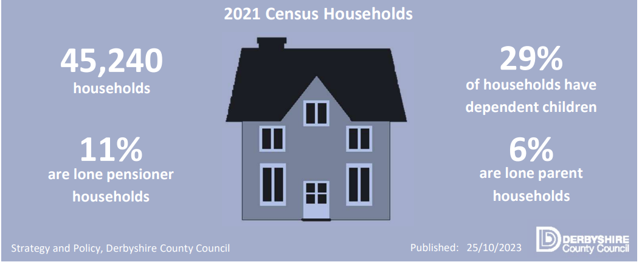

[Area Profile Tool 2023 0.02.xlsm (derbyshire.gov.uk)](https://observatory.derbyshire.gov.uk/wp-content/uploads/reports/profiles/area_profiles/district/South_Derbyshire_Area_Profile.pdf)

**Actions 2024/25**

All projects crosscut through the action plans five main priorities; however they have been organised into the table by primary priority area.

These projects are supported by:

* Partner capacity and resources
* Community Leaders
* Match funding
* Derbyshire County Council Public Health funding: Small Grants Fund administered by South Derbyshire CVS, Social Connectedness and Community Connectors projects, and the Raising Aspirations programme
* Locality Public Health Team
* Joint funded South Derbyshire District Council Health Partnership Manager (SDDC/ DCC PH locality funding)

|  |  |  |
| --- | --- | --- |
| **PRIORITY** | **PROJECT** | **OUTPUTS** |
| **Health inequalities between different communities are reduced by building community resilience** | Community Connectors Network | Develop a network to share Covid-19 and other health and wellbeing messages across communities in South Derbyshire. |
| Oral Health | Support preventative measures to maintaining good oral health for children and adults |
| Small Grants Scheme including 5 Ways to Wellbeing | Develop and support the implementation of the small grants scheme |
| South Derbyshire Financial Inclusion Group | Maximise financial inclusion across the partnership. |
| South Derbyshire Food Hub | Provide holistic, wrap around support to service users and emergency food parcels. |
| Community Based Job Club | Build confidence and motivation, develop / increase IT skills, use Universal Job Match, CV writing and interview skills. |
| Cost of Living Support Leaflet | Financial support signposting leaflet delivered to every household in South Derbyshire. |
| **People are supported to move more and become more active in everyday life** | Live Life Better Derbyshire | Supporting people to feel fitter, lose weight or quit smoking. |
| Walk Derbyshire Pilot | Community engagement and co-production pilot that will develop understanding of the barriers and opportunities to support residents to walk more. |
| Beat the Street | Support the development of the game phase and long-term sustainability. |
| Home from Hospital | Provide practical support for vulnerable people leaving hospital, or those living at home but at risk of being admitted. |
| Time Swap Derbyshire | Time Swap is an initiative that encourages local communities to help each other by sharing time and talents. |
| **People are supported to age well, including those living with dementia and other long-term conditions,**  **and their carers** | Melbourne Dementia Cafe | Monthly dementia café for people living with dementia and their carers & family. |
| Connect South Derbyshire | Develop place-based networks to strengthen the VCSE infrastructure, and support community groups to deliver activities to reduce social isolation and loneliness such as a dementia friendly café. |
| Joined Up Care Derbyshire -Team Up | Support South Derbyshire Place Alliance Group to understand the community activity available to support Team Up initiatives (falls recovery, urgent care response, home visiting). |
| Live Stronger for Longer (Age UK Derby & Derbyshire) | The service supports older people at risk of falls or seeking to improve and maintain their strength and balance. |
| **Improving emotional health and mental wellbeing** | Footsteps Bereavement Group | Support group for anyone who has been has ever been bereaved. |
| South Derbyshire CVS Mental Wellbeing Support Service | Support Service that helps people with their day to day living and long-term mental wellbeing. |
| Social Prescribing | Support for people over the age of 18 who are looking for support to take control of their health and wellbeing. |
| Living Well | Short term care packages (up to 12 weeks) for people who need support with their mental health and wellbeing. |
| **Enable children and young people to start well** | Raising Aspirations (Direct Education Business Partnership) | Delivery of Right Routes (KS 4) programme in The Pingle Academy and The William Allitt Academy.  Delivery of Pathways (KS4 & 5) to Success at South Derbyshire Support Centre. |
| Sports Mentoring | Deliver a programme of intensive one to one sports mentoring sessions for vulnerable children and young people between the ages of 8-16 years old. |
| Child Healthy Weight Whole System Approach | Support the LLBD Children’s Choice offer and raise awareness of the HENRY programme. |
| Parental Education Growth Support | Supports the emotional wellbeing and resilience of those experiencing child to parent abuse. |
| Resilient Me (SDDC Active Schools Partnership) | 6-week programme focused on Year 5-6 and Year 7-8 students to support school transition. |
| Family Support Derbyshire | Support disadvantaged families to achieve their full potential and enable parents to give their children the best possible start in life. |

**Appendix**

**Appendix 1.**



**Appendix 2.**



**Appendix 3.**



**Appendix 4.**



**References**

[Derbyshire Health and Wellbeing Strategy 2018-2023](https://www.derbyshire.gov.uk/site-elements/documents/pdf/social-health/health-and-wellbeing/about-public-health/health-and-wellbeing-board/health-and-wellbeing-strategy/derbyshire-health-and-wellbeing-strategy-2018-to-2023.pdf)

[Index of Multiple Deprivation (2019](https://observatory.derbyshire.gov.uk/poverty-and-deprivation-imd/))

[Public Health England Health Profiles](http://www.healthprofiles.info)

[Public Health England Local Health](http://www.localhealth.org.uk/)

[South Derbyshire District Council 2022 Air Quality Annual Status Report (ASR)](https://www.southderbyshire.gov.uk/our-services/environment/noise/pollution/air-quality)

[Derbyshire Observatory](https://observatory.derbyshire.gov.uk/IAS/)

[Social Mobility in Great Britain Report 2017](https://www.gov.uk/government/uploads/system/uploads/attachment_data/file/662744/State_of_the_Nation_2017_-_Social_Mobility_in_Great_Britain.pdf)