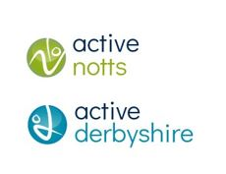

**Opening School Facilities – Year 2 end of year report**

Opening Schools Facilities (OSF) is a Department for Education fundingprogramme to support the goals of the School Sport and Activity Action Plan. The three-year investment aims to find local solutions for long term changes in behaviour, leading to more people being active in areas that need it most.

OSF aims to support schools to open their facilities outside of the normal school dayto allow children and young people and the wider community to access more opportunities to be physically active.

The programme aims to tackle inequalities, specifically focused on the following priority groups:

* Disabled people/those with long term health conditions
* People from lower socio-economic communities
* Women and girls
* People from ethnically diverse communities

Activities should be based on youth voice, engaging both the school and wider communities and developing a sustainable workforce.

The aims of OSF align with [Making our Move](https://makingourmove.org.uk/), our shared vision for Uniting the Movement in Notts and Derbyshire, and the shared aim of enabling children and young people to have positive experiences of being active throughout their childhood.

**How were schools identified?**

Schools were chosen based on their data, looking at the percentage of students on Free School Meals, with Special Educational Needs & Disabilities and with English as an Additional Language, against the national average. Key partners from education and health, along with the APT place team, also gave insight into schools based on lived experience and previous work.

**Timescales**

**Year 1: January 2023 – March 2023**

A total of 39 schools applied and £540,062.70 funding allocated (average of £13,848 per school).

Due to the delayed announcement of the programme, schools had short timescales to create their plans in year 1. Funding was primarily spent on equipment, storage and staff training, to enable delivery in year 2.

**Year 2: April 2023 – March 2024**

A total of 55 schoolsapplied and £815,387.98funding allocated (average of £14,825 per school).

In year 2, funding has been spent on a wide variety of resources, including equipment and storage, CPD for staff and young leader courses, community clubs, short-term staffing costs, external coaching costs, pool hire, lifeguards and transport for swimming.

**Year 3: April 2024 – March 2025**

Target of 70 schools and £870,000 of funding available.

**School commitment:**

Schools are required to be part of the programme until March 2025 i.e. schools who joined in year 1 will be in the programme and receive funding for 3 years, new schools in year 2 will be in the programme and receive funding for 2 years, and new schools in year 3 will be in the programme and receive funding for that year only.

Schools receiving funding are required to deliver a minimum 12-week programme for each of their chosen activities, for each year of funding. They must also agree to participate in the national evaluation which includes collecting participation figures from children & young people and community sessions. All activities must be new or additional to what is already taking place.

**What can the funding be used for?**

* Support schools to open to the community
* Help schools with pools to safely re-open
* Purchase additional sports, activity and storage equipment
* Improve accessibility of school's sports facilities for SEND pupils
* Cover additional short-term staffing challenges
* Provide CPD (Continued Professional Development) opportunities for staff/young leaders

**Headlines – Year 2 (April 2023 – March 2024)**

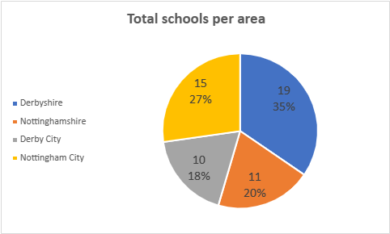A total of 55 schoolsapplied for funding in Year 2, including 2 primary schools, 47 secondary schools and 6 special schools.

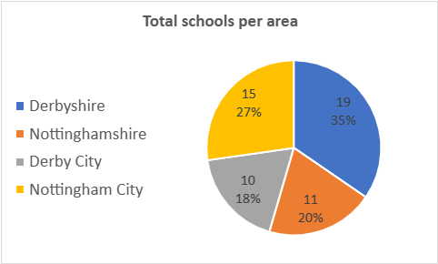

Overall, £815,387.98funding was allocated and the overall spend totaled £593,845.37.

Underspend was due to schools not spending their full allocation due to various reasons, some schools not spending any allocation due to staffing shortages and school budgets, and some schools including VAT costs within their original funding allocation bids, despite confirming that VAT costs cannot be covered as part of the funding.

Funding was spent on a wide variety of resources, including equipment and storage, CPD for staff and young leader courses, community clubs, short-term staffing costs, external coaching costs, pool hire, lifeguards and transport for swimming.

**DfE key performance indicators in Year 2**

For Year 2 of the programme, we were given very clear targets from the Department for Education (DfE) to engage 5,745 young people and 1,916 community users in sport and physical activity on 57 school sites.

**Year 2 overall outcomes**

In Year 2 of the programme, 55 schools delivered a total of 3,045 physical activity sessions for 8,783 young people and 655 community users. We know this because of the monthly participation data that schools have submitted for their activities.

Of the 55 schools involved in the programme; 98% fall in a 1-5 score based on Pupil IDACI and 69% fall in a 1-5 score based on School IDACI (Index Deprivation Affecting Children Index), therefore prioritising those in disadvantaged areas.

As part of the programme, there has been emphasis on swimming and water safety, to increase the number of children and young people able to swim 25m. 16 schools in Year 2 chose swimming as a project, many of those included family swimming sessions as well.

**Year 2 Projects**

A total of 124 projects took place in Year 2, all based around youth voice. As represented on the graph below, the most popular activities chosen were Multi-Sport, Fitness and Swimming. 30 different activities were chosen across the schools, with more unusual choices including American Football, Street Hockey and Pool.

**Priority groups**

The programme aims to tackle inequalities, specifically focused on the following priority groups:

* Disabled people/those with long term health conditions (SEND)
* People from lower socio-economic communities (FSM)
* Women and girls (GIRLS)
* People from ethnically diverse communities (EDC)

Girls, students with SEND and those on Free School Meals were most chosen by schools. Ethnically Diverse Communities were the least chosen group.

Students with SEND was the most chosen priority group for projects, followed by Girls and those on Free School Meals. Ethnically Diverse Communities were the least chosen group.

**Analysis of feedback gained from OSF Project Leads *(from 16 schools)***

*“We have been able to run many more afterschool clubs offering a wide variety of sports to suit many. We have been able to run multiple sessions for different year groups which is often a barrier to participation.”*

*“The funding we have received for new football equipment has allowed the Alfreton Town Juniors to expand the club massively. This has given the local community more opportunity to participate in physical activity and sport.”*

*“it’s creating a culture in school that focuses on overall health and wellbeing, and we hope that this will continue in the future lives of all our young people.”*

**Analysis of feedback gained from Young People participating in OSF activities *(85 students from 8 schools)***

*“It’s fun and i enjoy being with my friends and it’s a nice environment for everybody”*

*“The feeling after finishing exercising is amazing and I enjoy the challenge and hard work that has to be put into it"*

*"It is sociable, learnt new skills and was able to enjoy competitive situations"*

*“It would be better to have a bigger space and to have more equipment to use.”*

*“More equipment and access to pathways including more competitions.”*

**Case Studies**

At the end of the second year, we have gathered a few case studies to share some of what the schools have been doing with the funding.

Brackenfield Special School in Long Eaton have been part of OSF since year 1 are breaking down barriers to provide an after-school offer for the young people. Learn more about it by watching this short video.

[[Brackenfield SEND School OSF Case Study Video](https://www.youtube.com/watch?v=WDs3S3AbqB8)](https://www.youtube.com/watch?v=WDs3S3AbqB8)

St Andrew’s Academy in Derby have been making the most of the funding by offering their young people a range of new activities. Some of their work is captured below.

[St Andrew's Academy OSF Case Study](https://makingourmove.org.uk/wp-content/uploads/2024/07/St-Andrews-Derby.pdf)