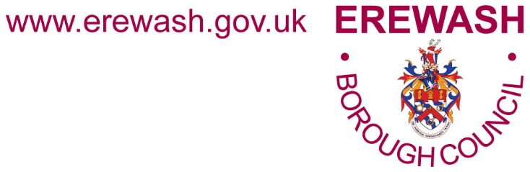

**JOB VACANCY**

**JOB VACANCY**

**PHYSICAL ACTIVITY INCLUSION OFFICER**

**Directorate: Environmental & Community Services**

**Department: Wellbeing & Culture Service**

**Hours: Part Time - 22.2 hours per week**

**Type: Temporary* for up to 18 months - further extensions are subject to continued external grant funding**

**Salary: GRADE E - £27,803 - £31,364 (pro rata for part time working) (pay award pending)**

**Location: Erewash Museum, High Street, Ilkeston, Derbyshire, DE7 5JA**

**There are around** **27,000 adults in Erewash experiencing being inactive and almost 10,000 of those people have a limiting illness, long-term condition and/or disability.**

**Would you like to join our innovative team as the Physical Activity Inclusion Officer and drive partnership working to make physical activity more accessible for people living with a limiting illness, long-term condition and/or disability?**

An exciting opportunity is available for a highly motivated and committed individual to join Erewash Borough Council’s Wellbeing and Culture Service working within its Community Health and Wellbeing Development Team.

The Physical Activity Inclusion Officer will drive the ‘All Move in Erewash’ initiative in partnership with key stakeholders. The successful candidate will be required to use their partnership skills to develop a collective understanding of how to create opportunities for moving every day for residents living with a limiting illness, long term condition or disability.

The ideal candidate will have experience of working with partners and influencing stakeholders in sectors such as health and wellbeing, community, voluntary, and statutory organisations. The ideal candidate will understand health inequalities and an awareness of equality and diversity.

Good communication skills are required to effectively listen to the challenges of people with lived experience of a limiting illness, long term condition or disability and the ability to share the information with key partners. Experience of leading and coordinating similar health and activity initiatives is desirable.

A workplace culture exists within the Wellbeing and Culture Service where continual professional advancement through training and learning will be supported and encouraged.

Hours of work will mainly be daytime working but may include occasional evenings, weekends and during holiday periods.

Please note this post requires the successful candidate to undertake a satisfactory Enhanced Disclosure and Barring Service check.

**If you wish to join a multi-disciplinary service that values a collective work ethic, innovative thinking, and excellent service delivery then this could be the opportunity for you.**

**If you would like an informal discussion about this role please call Becci Carter, Community Health and Wellbeing Development Officer on 07542 228281 or email** [**becci.carter@erewash.gov.uk**](mailto:becci.carter@erewash.gov.uk) **or Jordan Hedges, Community Health and Wellbeing Development Team Leader on 07842 231338 or email** [**jordan.hedges@erewash.gov.uk**](mailto:jordan.hedges@erewash.gov.uk)

**Benefits of Working for Us**

As part of the excellent package of benefits the council offers, you will have access to:

* Generous annual leave package – a pro rata entitlement to 29 days annual leave (rising to 33 days after 5 years’ continuous service) plus 8 bank holidays a year (pro rata).
* Family friendly flexible and hybrid/home working policies available.
* Option to join the Local Government Pension Scheme (LGPS) plus access to a salary sacrifice scheme for added voluntary pension contributions.
* Subsidised leisure membership through the Fit for Work scheme.
* Free workplace car parking within the Borough.
* Opportunities for training, learning and continuous professional development.

*This position is temporary for up to 18 months funded through external grant funding and, whilst further extensions to the post cannot be guaranteed by the Council, the Wellbeing and Culture Service strives to continually secure external grant funding to ensure services remain operational.

**The closing date for applications is Sunday 9th June 2024 at midnight.**

**How to Apply**

Interested candidates can apply with a CV and a supporting statement, clearly demonstrating suitability and experience for the role.

To submit a CV please click on the **'Apply Online'**icon located at the foot of the page. You will be requested to provide some basic information before you upload your CV.

For further information about working for Erewash Borough Council and how to apply for this job please visit our website at <https://www.erewash.gov.uk/jobs-section/jobs.html>

Alternatively, an application form and job description are available from Human Resources, Erewash Borough Council, Town Hall, Wharncliffe Road, Ilkeston, Derbyshire DE7 5RP, Telephone: 0115 931 6000 (24 hr. voicemail) or e-mail: [jobs@erewash.gov.uk](mailto:jobs@erewash.gov.uk)

If you are a current employee of Erewash Borough Council and you wish to apply for this vacancy, you must apply through your Employee Self Service account. If you do not have access to Employee Self Service, you must complete a paper or word version of Erewash Borough Council’s job application form.

The Council is positive about disabled people and those who meet the essential shortlisting requirements will be guaranteed an interview.

The Council also supports the Armed Forces Covenant and those who have previously worked in the armed forces and meet the essential shortlisting criteria will be guaranteed an interview.

Please ensure that you make it clear on your application form that you wish to be considered under these criteria.