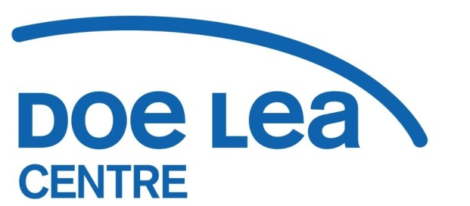Doe Lea Centre  
Mansfield Road, Doe Lea  
Derbyshire, S44 5PD  
01246 850209  
[info@doelea.org.uk](mailto:info@doelea.org.uk)  
Registered Charity Number: 508572

**Cultural Corridor Project Development Worker  
Fixed Term to March 2025**

Do you have a passion for the Arts, Culture and Community?

Are you a confident, well organised person who can bring people together to experience events, shows and artistic activities?

If so, then we’d love to hear from you.

The Ault Hucknall Parish Community Association is looking to recruit a Project Development Worker to lead on Bolsover District Council’s Cultural Corridor Partnership Project.

Promoting cultural and artistic activities along the “Cultural Corridor” (the villages along the A617 from Stainsby to Pleasley) is the key responsibility of the role alongside development and delivery of innovative arts intervention projects and experiences in partnership with local communities. Monitoring reports, liaison and outreach, volunteer development and retention and digital   
communication also form a large part of the role.

**Salary: £28,900 FTE  
Hours: 18.5 hours per week, fixed term contract to end of March 2025  
Pension: 3% contribution from Ault Hucknall Parish Community Association  
Responsible to: Community Development and Business Manager  
   
Closing date for applications: Sunday 5th November 2023  
Interview date: Friday 10th November 2023  
For an application pack please contact:** [**richfearn@doelea.org.uk**](mailto:richfearn@doelea.org.uk)